Jerry Pinkney: Imaginings
An Artist’s Exploration of Images and Words
Organized by Norman Rockwell Museum
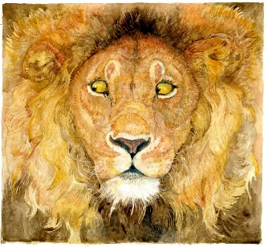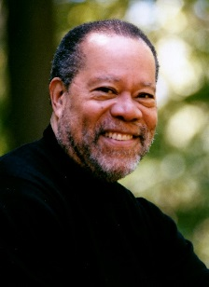
Across his fifty-year journey as an illustrator, Jerry Pinkney has cast a warm, curious eye on our world to create images that reflect his passion for life, his love of family and community, and his deep and abiding engagement with the rich complexities of history. Initially created for the covers and pages of periodicals, postage stamps, greeting cards, product advertisements, and well-traveled historic sites, Pinkney’s artworks have also appeared in more than one hundred books, garnering well-deserved acclaim. Jerry Pinkney: Imaginings explores the artist’s engagement with literature, and the process of creating meaningful visual solutions that expand and enliven a narrative. Artworks inspired by classic and contemporary literature, and by well-loved folk tales and fairy tales, will be on view.

“I am a storyteller at heart. There is something special about knowing that your stories can alter the way people see the world, and their place within it.”

-Jerry Pinkney

Exhibition period: eight to twelve weeks

Contents: approximately 120 original artworks; reference materials; studies; introductory and biographical panels and object/extended identification labels

Insurance: all risk fine arts, wall to wall

Security: high, all works must be within sight of a trained security officer/staff member at all times during public hours

Environment: light level -18 to 22 foot candles for paintings and 5 to 7 foot candles for works on paper and other light restricted objects; humidity -50% plus or minus 5% and temperature 68 - 72 degrees, no direct sunlight and no direct contact with light fixtures or heating, air conditioning, ventilation, or electrical outlets

Space: Approximately 3,000 to 3,500 square feet

For further information, please contact Mary Melius at 413.931.2245 or mmelius@nrm.org

