Exhibition Proposal
My exhibition is about 3D stuff, like the toys, stop motion animation characters, which can be displayed in an illustrated way.

As an illustrator, illustrations for children have taken a big part of my creations. When I create these artworks, the things influence me the most are the toys I have played in my childhood and the animation I loved to watch.

As for toys, they provide entertainment and education function at the same time. For example, some animal like and human like toys, which have cute outlooks, they served as a role to teach children about acquainting themselves and communicating with they others. If the toy developers put some abnormal elements in the toys, the effect will be better as they will broad children’s limitation of imagination. There is a good example of the famous toy, the transfer. Although it has pertinence in gender, we still cannot deny its success in developing children’s creativity and imagination.

As for animations, I prefer the 3D stop motion animations based on hand craft rather than the other animations, especially the animations totally based on computer technology. In the over 100 years history of stop motion animation, a lot of brilliant works influenced generations of children. And some of them are still very popular all these days. Cheburashka is a case in point. This Russian monkey like character with big ears, which firstly appeared on the screen in 1969, gave people a precious memory of that age, and as for nowadays, Cheburashka is still very popular among teenagers especially in Asian country, like Japan. A toy company in Japan even has developed a lot of products base on Cheburashka.

Maybe strictly speaking, exhibition of lovely stuff related photos couldn’t be regarded as an illustration-based exhibition. However, in my opinion, toys and animation characters vary from the large group of “lovely stuff” -- most of the original designs of them are created by illustrators, and whatever backgrounds they are in, realistic or painted, they all almost work well with the background. Anyway, except for the photos of the characters, some original designs of them will also be displayed in my exhibition.

The three panels of my exhibitions are about Cheburashka, Kewpie Dolls and vintage paper dolls. The exhibition will not only benefit the children, but also give a break to adults. I believe through seeing the exhibition, adults will memorize their childhood.

Cheburashka

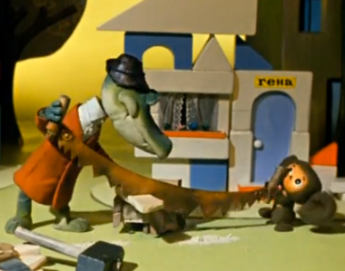
Cheburashka, also known as Topple in earlier English translations, is a stop motion animation character based on a Soviet writer Eduard Uspensky’s children’s literature published in 1966. And the animation was released in 1969. Cheburashka is an iconic Russian classic cartoon character, he is a little funny monkey like creature who lives in a tropical forest, and one day he is accidently sent to a crocodile like character’s house in a box, and later they have a wonderful adventure together in the city.
The stop motion animation was so outstanding because of its advanced skill at that time and terrific character design. The colorful world in the animation was created in an illustrated way although they were 3 dimensional, and that’s why every single screenshot in the animation can be regarded as an illustration. What’s more, the supports in the animation are also really very vivid. A good example is a group of the Russian scouts. They are dedicatedly designed and the looks of them can still be found in the animation or illustrations nowadays.
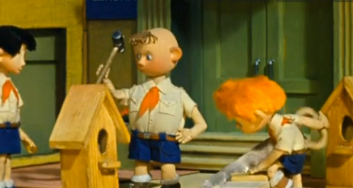
This European character’s design is cute and sweet, his variety in emotion is subtle, which also fits Asian audiences’ flavor, and that’s why a Japanese animation company makes a series remaster editions and new series for this character.

My proposal for this panel is to display the design of Cheburashka and his friends in both illustrated way and photographic way.

Kewpie Dolls
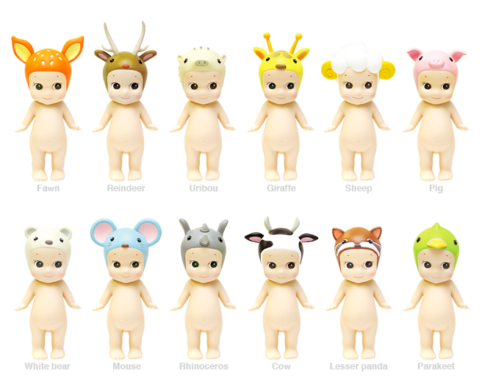
Kewpie is a brand of dolls and figurines that were initially conceived as comic strip characters by Rose O’Neill. It’s cute with an evil snicker. In 1909, O’Neill began to illustrate and sell paper doll version of the Kewpies. And later in 1912, a company in Waltershausen in Germany began to produce the bisque dolls of Kewpies in 1912. In the early twentieth century, Kewpie became extremely popular. Through the composition version, celluloid version, finally in 1949, Effanbee created the first hard plastic version of Kewpie. Later soft rubber and vinyl versions of Kewpie also came out in 1960s and 1990s.
Since Kewpie has such a long history compared to the other doll designed by artists, a lot of derivatives based on Kewpie dolls appeared. For instance, it is the mascot of a chain of fast food restaurants called as Kewpee Hamburgers; Kewpie Corporation is also a Japanese food manufacture, which is famous for its Japanese mayonnaise. A very interesting example is called as Kewpie Fusion, which is a popular Japanese anime whose characters are based upon O’Neill’s Kewpie dolls. The producer combines Kewpie with many famous characters and item from animation characters to celebrities, fruits to animals, and makes Kewpie dolls become more popular in Asian countries. Some unofficial producers also have done a lot of cool stuff about Kewpie dolls, and give this over 100 year old character continued popularity.

Vintage Paper Dolls
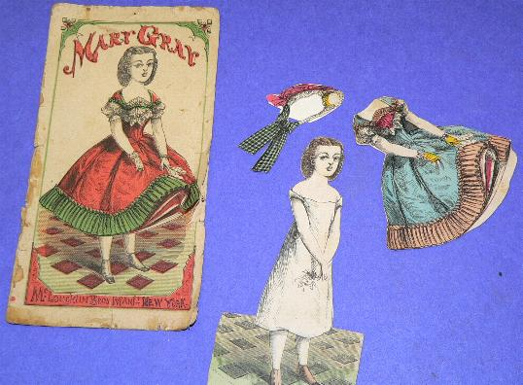
Paper dolls have been around as long as there has been paper, they are figures cut out of paper or thin card board, with separate clothes those are also made of paper, and amounts of them are with movable joints. They are not as expensive as the plastic or bisque dolls, and they also easy to make, so that’s why they have been create for almost 200 years as children’s toys. Even nowadays, still a lot of artists are making paper dolls to turn them into an art form, like appearing in magazine and newspapers.
In Europe, particularly France, the first paper dolls were made during the mid-18th century. They were created to entertain adults and spread throughout high society. And later, they just become more reachable because of the easy process of making them, and good entertainment from them. As time goes by, more and more companies start to make paper dolls until now.
Vintage hand-illustrated paper dolls are becoming more and more rare due to paper aging issues. Time gives them stains and makes them faded, but the exquisite illustrations and vintage look costumes make the toys not only toys, but pieces of art works.

Reference from: www.wikipidia.com

