PENCIL COMICS

Introduction/Overview of Exhibition Topic (about 350-400 words)

In tradition comics, the initial step has been to first ‘pencil’ out the story. This means the artist creates a loose rendering of what he/she wants the panels to look like, with the intention of going back over it with ink to create the finished art. The penciling stage will most likely be erased or covered up. With the increasing popularity of Photoshop and digital rendering, many artists create comics entirely on the computer, and the pencil stage has become largely obsolete. However, this isn’t the case for all artists. In fact, there are many new artists creating comics that could be considered underground, Avant-garde, experimental, or ‘art comics’, who choose to explore this hidden stage of comics’ creation. By choosing to use mostly pencil and/or colored pencil, this growing genre of comics responds directly to the increasingly digitized art found in comics. Digital art of mainstream comics suggests a level of polish that rejects the spontaneity of the artists hand in the work and the authenticity of individual vision. Pencil comics reveal the process of creation—the smudges and erases, the shaky line and scribble. The reader has the sense of seeing something as it is being created, and that hasn’t been worked over to a ‘finished’ state. One might feel as if they are peaking into a sketchbook or personal journal. This creates a level of intimacy with the reader and vulnerability in the art unique to pencil comics. The pencil comic is inherently democratic. There is no fancy software or editors or printing processes. Anyone with a pencil and a piece of paper can create them. The egalitarian nature of pencil comics contributes to why they are so often the most progressive and experimental comics being created. New ideas can be expressed and shared, without a concern for salability or conventional standards in comics. Young artists can create fresh looking art without needing the approval of older creators who may be stuck in traditional notions of what comics should look like. This exhibition explores several young artists creating some of the most interesting and exceptional pencil comics today. Their work appears on blogs, in zines, through alternative press, and in galleries. Some work as illustrators with their work appearing on a variety of products, other run their own small presses that support artists they believe in. The richness of their work, their careers, and their vision represent the compelling and growing world of pencil comics.

Reconstructing Form

The following artists, Aidan Koch and Austin English, use analog mediums to explore color, form, and line, to create unique and experimental images. They break down traditional representational forms found in comics to make expressive abstracted images. Radically breaking the rules of what constitutes the human form or representational reality, Koch and English use comics as a vehicle for questioning and reinterpreting conventional image making.

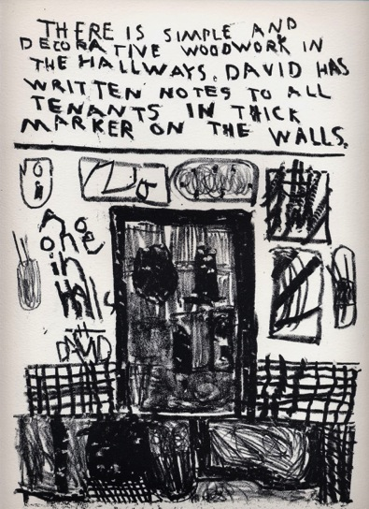
Austin English
Excerpt from I Used to Live on Ridge Street
Lithograph

This lithograph is typical of English’s expressive mark making combined with poetic, descriptive language. The bold line work is reminiscent of the German expressionist woodcuts of Ernst Ludwig Kirchner, and the abstracted nature of his form suggests influence of the American painter Cy Twombly. This work walks the shaky line between these high art influences, and the ‘low’ art created by children or the insane. English’s sensitivity to this dichotomy gives his work a sense of freedom and psychological power.

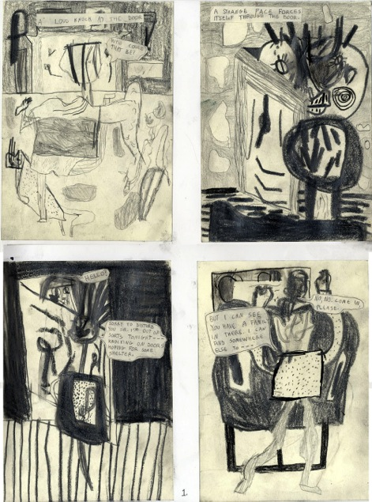

Austin English
Excerpt from Here I Am
Graphite

By abstracting form to a point where it can be difficult to distinguish human forms from the shapes and marks that make up the imaginary landscape, English bring the viewer deep into his strange world. There is a sense of confusion and abandonment. We are lost in a world where everyone is a stranger; they appear and disappear without explanation.

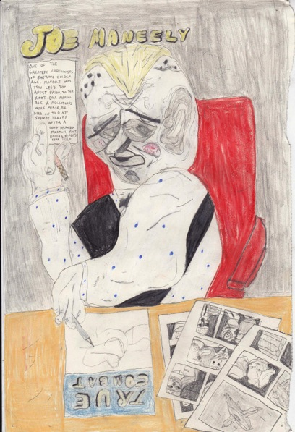
Austin English
Joe Maneely, 2013
Graphite and Colored Pencil

In this piece, English pays tribute to Joe Maneely, who he calls ‘one of the greatest cartoonists of the late golden age’. This later work shows a move towards representational portraiture. There is greater clarity in the image—the figure is distinct from the table, the comics splayed out on the table, we can even distinguish the outfit the subject wears. English continues to play freely with form, and the clearer representation only adds to his distorted figures. In a similar vein as the portraits of German painter Otto Dix, the stylization adds qualities of biting satire and devastating human folly.

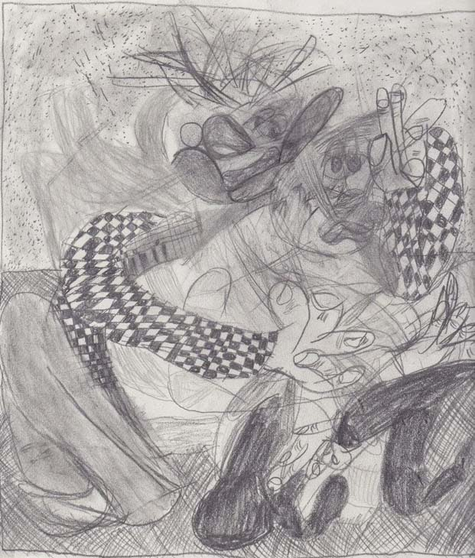

Austin English
Two Guys, 2012
Graphite

Surrealist and abstract—the title of this piece directs us to look for human form in the chaotic mark making. Much like the cubist painting ‘Nude Descending Staircase’, English challenges us to reconsider representation of the human form.

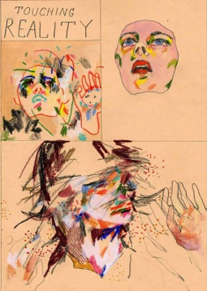
Aidan Koch
Touching Reality
Graphite and Colored Pencil

In this four-panel comic, form is deconstructed incrementally before our eyes. The phrase ‘touching reality’ is written out in the first panel, suggesting this is the topic Koch is address-the way we interact and interpret reality. A free floating face becomes obscured by line and color before breaking apart and actually merging with these colors. There is a sense of movement, of wonder and a visual break with conventional forms.

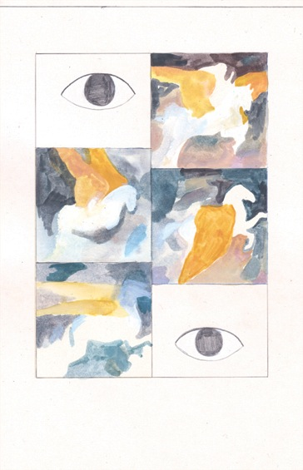
Aidan Koch
Excerpt from Q
Graphite and Watercolor

This page begins and ends with the simple form suggesting an eye. Again, Koch frames the primary concern of her work—seeing. She questions how we see and interpret images. In the second panel, it appears there are areas of color that are blended and layered, with no particular form or images. The following panels suggest a winged horse moving through this world of color. The outlines of the horse are ill defined, there are no details, only the ethereal suggestion of form.

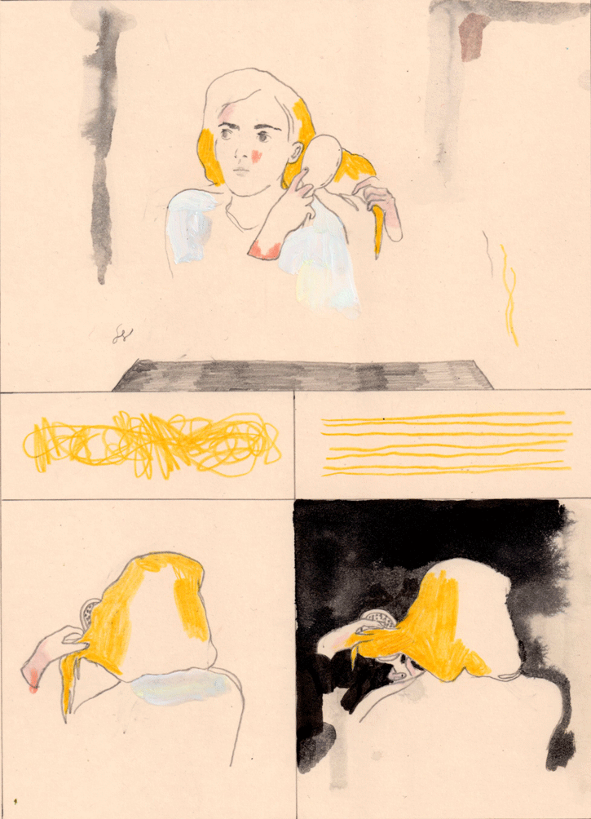
Aidan Koch
Excerpt from The Blonde Woman, 2012
Graphite, Colored Pencil, and Watercolor
Study Group

Koch introduces the image of a girl brushing her hair. By contextualizing the following panels with this initial knowledge, the marks and forms take on new meaning. The lines and squiggles appearing mid page suggest hair, although they take a different texture and form than what seems to be on the girls head. Koch masterfully uses the least amount of visual material possible that will still offer enough information to see the back of her head as she continues to brush.

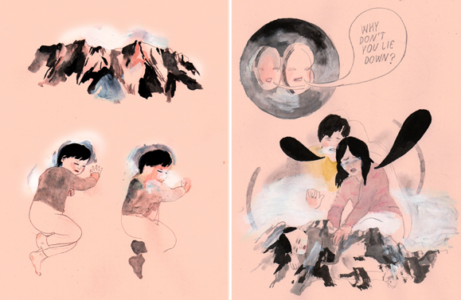
Aidan Koch
Pencil and Watercolor

A smear, smudges, eraser marks, incomplete faces and bodies—Koch breaks open the art form of comics with fearlessness and mastery of analog materials.

Reconstructing Narrative

Traditionally, comics follow understandable plots, perpetuated by conventional narrative devices such as third person narration and first person dialogue. These story-telling devices are easily recognizable to readers, allowing them to focus on the characters and plot. The following artists, Blaise Larmee and Ward Zwart, challenge typical comics narrative by using unconventional story telling techniques—characters come in and out of the story without explanation; at times without entering the frame, disjointed narration seemingly unrelated to images, there are nonsensical scene cuts, or an abstracted or vague narrative description. The result is reminiscent of a surrealist film or literary ‘cut-up’, creating a tone or atmosphere instead of a straightforward narrative plot.

Blaise Larmee
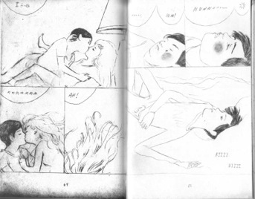
Blaise Larmee
Excerpt from Young Lions, 2010
Graphite

Larmee’s first graphic novel, Young Lions, loosely follows the story of a group of young artists involved in vague relationships, going on vague adventures. Conversations are disjointed, random, or incomplete. They travel to different locations without thorough explanation. Most everything is unresolved. However, the drawings are beautiful, seductive, and evocative, and pull the reader through the story. There is a sense of immediacy and intimacy, both in the story telling and the visual style.

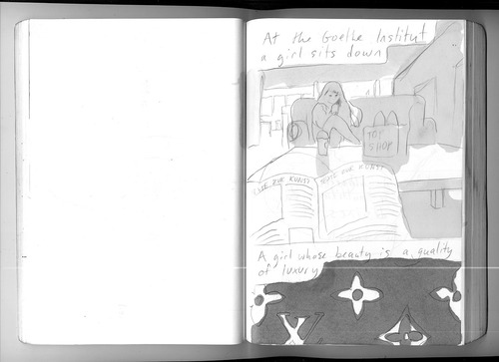

Blaise Larmee
Graphite and Ink

A page from Larmee’s personal journal contains a similar intimacy and poetic sensibilities as his more formal work. The narrative is his internal commentary and visual observations.

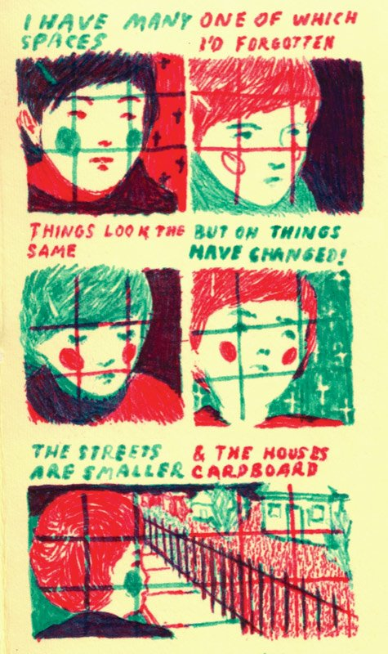

Blaise Larmee
Felt Marker

Again, we find ourselves in the middle of Larmee’s world without an explanation. Without knowledge of the character we are presented with or the place he occupies, we are introduced with his intimate thoughts and reflections. We are asked to abandon our expectations of traditional narrative devices and to surrender ourselves to the fluidity of Larmee’s storytelling.

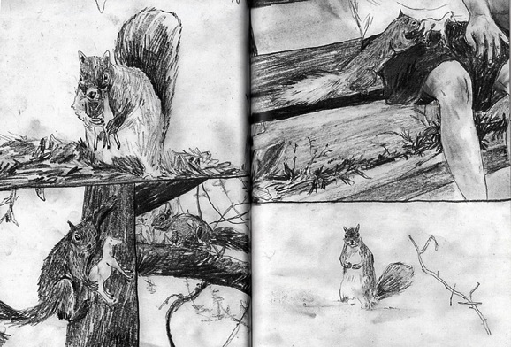Ward Zwart
Graphite
From Astral Talk

This excerpt is typical of Zwart’s cinematic storytelling. A squirrel brings a tiny toy horse and leaves it on a boys lap. These stark but beautiful pencil drawings bring us into this quiet moment and strange moment. There are many questions left unanswered and yet there is a feeling of completeness as we watch this simple action through.

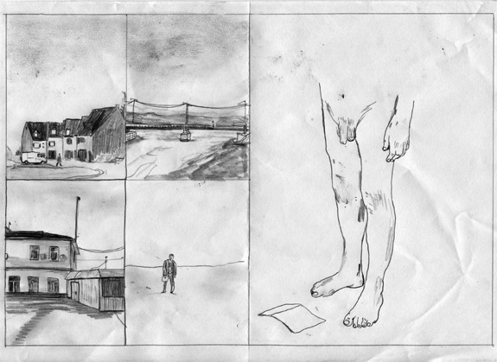
Ward Zwart
Total Man Child
Graphite

Zwart often starts his stories with a long shot of a town or cityscape, as if to comment on the banality of looking at things from the outside. In this piece, these images are juxtaposed with an awkward, intimate view of a flaccid penis. This figure has legs but no body. There is a note on the floor. There is a feeling of anxiety, self-loathing, and failure. The narrative is fragmented, things are missing, and yet the story feels familiar.

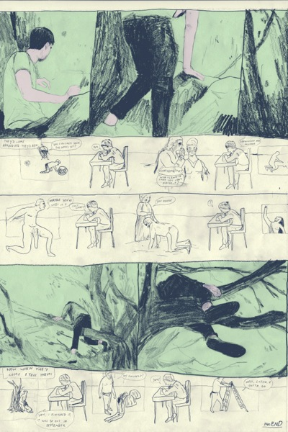
Ward Zwart
Graphite and Digital

Zwart uses primarily graphite in his work, but he doesn’t shy away from coloring digitally. Here he uses color beautifully and subtly to add to his work. The sweet mint green, the dark blue line work, the cream paper, and the nuanced pink he puts in for skin further the calm, dreamy tone of his work. In regards to narrative, he intersperses a comic strip of imaginary dialogue addressing his anxieties and pressure he feels around finishing his new novel between larger panels of a man climbing a tree. The narrative, although fragmented, suggests the experience of being human, in which often times the place our bodies are is not where our minds are.

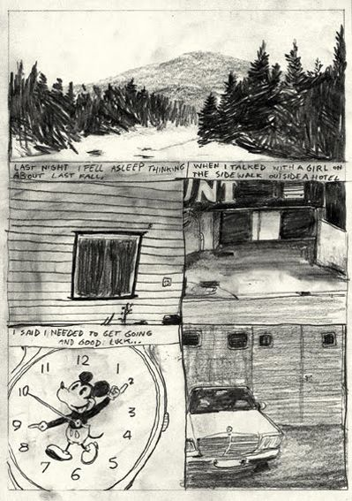
Ward Zwart
Graphite

Zwart’s comics are primarily psychological, and the narrative follows an internal or subject logic that serves to share his personal experiences. Not experiences of people or events, but the experience of being alive and inside his head. In this piece, the narration recalls the experience of lying in bed and thinking about something that happened the previous fall. The images—a mountain, a window, a Mickey Mouse watch—may suggest the narrator is walking around as he tells us of remembering his memory, or it may be images he is recalling from his memory. The specifics aren’t important; instead the focus is on the feelings experienced by the narrator—melancholy, loneliness, and regret.

Reconstructing Reality

Comics have often explored worlds different from the one we live in. The nature of drawing allows artists to exaggerate reality or create impossible things. The following artists, Amanda Vahamki and HTMLFlowers, bring to life unrealities with their own internal logic unlike anything seen in traditional comics. They create deeply emotionally evocative comics that are completely unique. From talking bears in Vahamaki’s The Bun Field, to the psychedelic landscapes found in the work of HTMLFlowers, these artists explore surrealist pencil comics in new and radical ways.

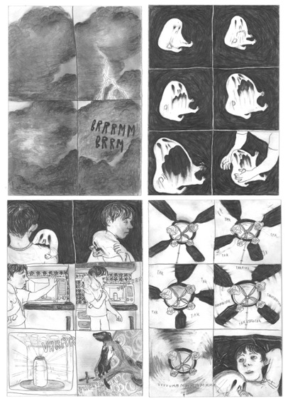
Amanda Vahamaki
The Night
Graphite

In this short story, a storm rages outside—inside a baby ghost cries for it’s young caretaker. He prepares a bottle in a microwave oven, the ceiling fan hums, and everything carrying on as normal. The ghost baby’s face expresses an agony beyond the capacity of a human baby, but his existence in this world is a mystery.

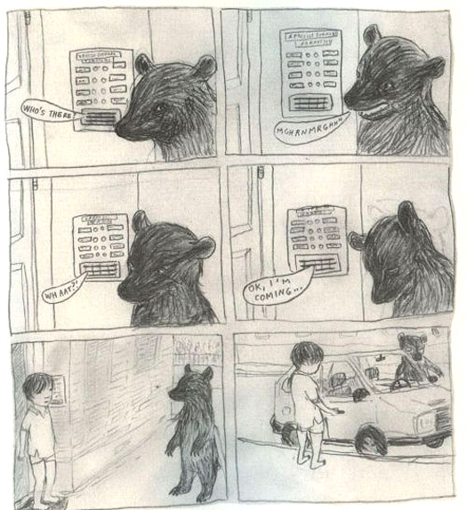
Amanda Vahamaki
The Bun Field, 2009
Graphite

Vahamki’s graphic novel ‘The Bun Field’ follows the adventures of a little boy as he moves through a surreal and sinister world. Animals and inanimate objects are personified, although their role and character is left largely unexplained. The world Vahamaki creates follows a fluid, dream-like logic. The characters play out repressed childhood fears, desires, and forgotten memories.

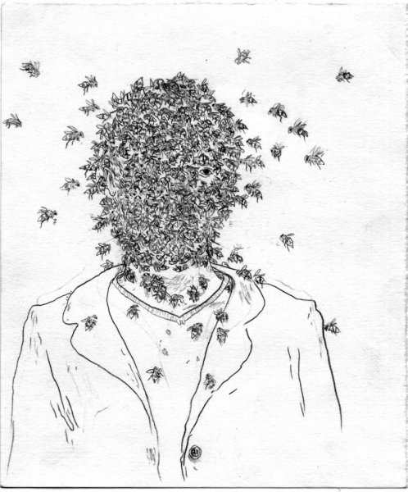
Amanda Vahamki
Souvlaki Circus, 2008
Graphite

Amanda Vahamki collaborated with artist Michelangelo Setola on Souvlaki Circus—a series of drawings based loosely on the theme of the relationship of humans and nature. Each piece is a surrealist visual metaphor, revealing psychological truths and human folly. There is a pervasive sense of dis-ease, humor, and mystery, executed with sensitivity and fearlessness.

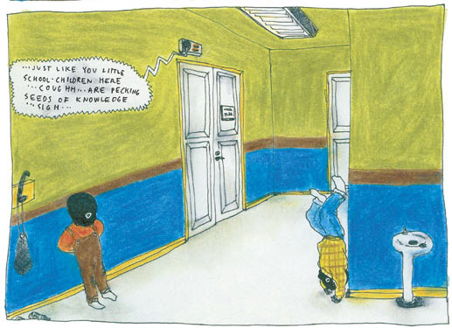
Amanda Vahamki
D&Q Showcase, 2008
Pencil and Colored Pencil

Vahamaki often takes the viewpoint of children, and her story for the Drawn and Quarterly Showcase in 2008 is no exception. Here we see children wearing ski masks making small mischiefs in the hallway of their school, clearly not in class where they are supposed to be. Vahamaki’s world IS the world of children—these stories highlight the absurdity and tragedy of the adult world.

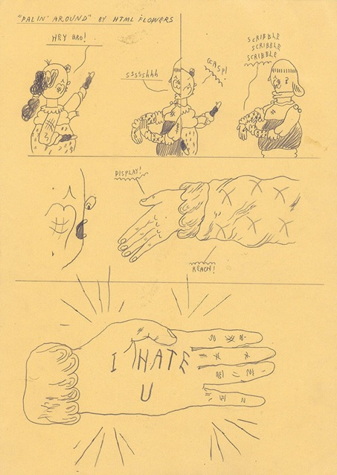

Grant Gronewold aka HTML Flowers
I Hate U
Graphite

Gronewold’s creative output, along with his personal photos, stories from everyday life including his struggles with substance abuse and Cystic Fibrosis, along with documentation of the tattoos his gives his friends and fans, appear on his Tumblr blog in what results in a kind of mash up diary scrapbook. He has a unique and distinctive style he uses to create a surreal personal landscape.

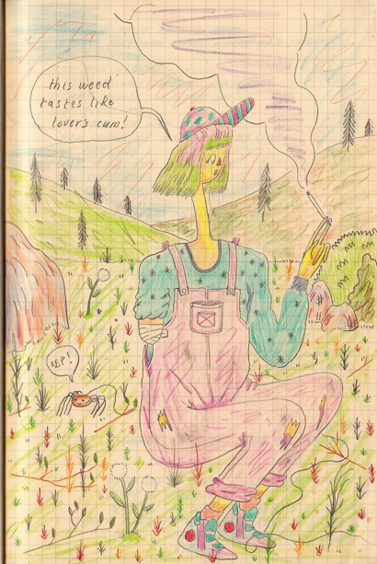
Grant Gronewold aka HTML Flowers
Train Drawing, 2014
Colored Pencil

This excerpt from Gronewold’s notebook he created while riding on a train reflects his approach to art making. He creates hid own magical world to cope with the real one, which he cannot control. His bright color palette and playful landscape is innocent and child-like, while the subject matter reflects the adult issues Gronewold faces—chronic illness, sexuality, and drug use.

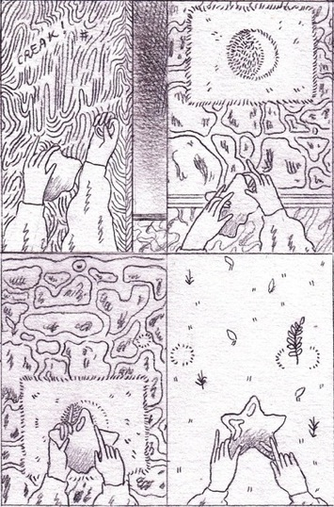
Grant Gronewold aka HTML Flowers
Excerpt from Universal Slim, 2013
Graphite

Gronewold creates his art with the intention of it being shared and experienced. Unable to work and faced with the realities of his illness on a daily basis, he prioritizes the way art connects him to other artists and his loyal fans. This means his world usually ends up on his blog where he can answer questions, or in collaborative zines with other artists, or on the skin of his friends and fans. A sense of hope, melancholy, and a desire to connect are characteristic of the world he creates.

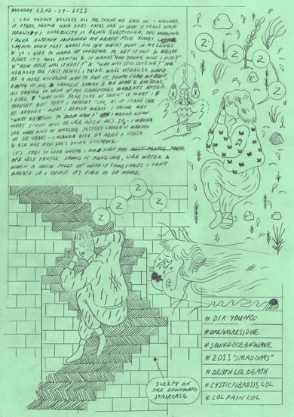

Grant Gronewold aka HTML Flowers
Sadness Diary 2013
Graphite

Gronewold’s surrealist world is a reflection of his internal one. Sometime he creates more formal comics although many are simply his personal diary. This is an example of the latter. His drawings are sweet and cute, but as we read his notes, we are let in on the grave nature of his subject matter. Here he states ‘this morning I have already imagined my death five times’, describing how the painful experience of mucus filing his lungs. He goes on to ask the chilling questions of a young person facing an early death: “ how young will I die? How much will it hurt? Who will still love me?” The drawing at the bottom of the page of a person sleeping on the “downward staircase” suggests a feeling of hopelessness or giving up in knowing he won’t live to see his family and friends grow old.

Exhibition Layout

Exhibition would occupy the first floor of a large house. The front room would be sparsely furnished with couches and chairs to sit on, and the books and zines of the artists on tables around so visitors could sit and read comics. The rest of the rooms would be empty, and the walls would full of original art. In the back there would be a ‘drawing room’ with places to sit and draw, with paper and materials provided. Visitors would be encouraged to hang up their drawings on the wall. There would also be a zine bin or bookcase in this room where people could leave their personal zines and or take other people’s zines for free.

